# Introduction about security:

* According to a 2018 WHO analytical report, road deaths are the 8th cause for all ages and the 1st for people aged 5 to 29.
* Mortality rates in low-income countries are 3 times higher than in high-income countries.

## Number of cars, income and deaths

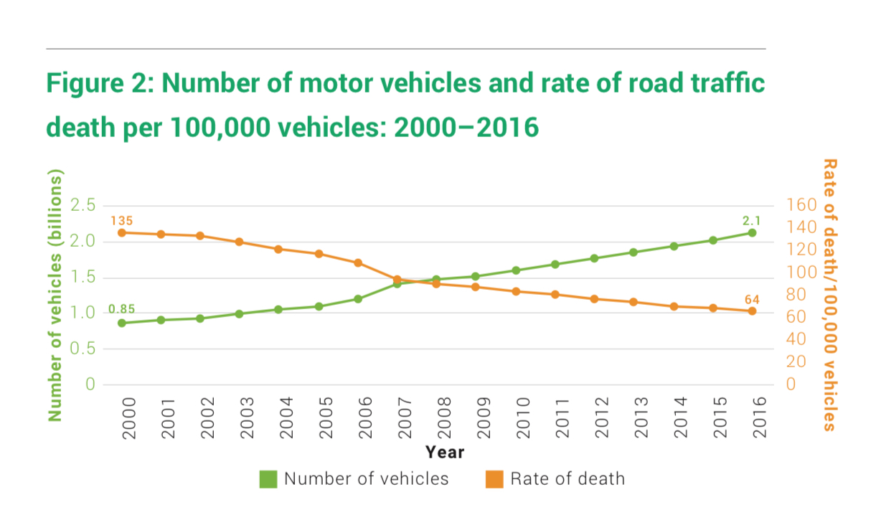

Since 2007, the number of cars in billions has always been higher than the number of deaths per 100 thousand cars, that is, safety in general has increased, but at the same time, the total number of annual deaths has only increased from 2000 to 2016 - from 1.15 million to 1.35. million

* No low-income country experienced a decline in road deaths from 2013 to 2017, while it increased in 60 middle-income countries over the same period, with 23 countries declining, while high-income countries income, it mostly decreased (25 versus 17).

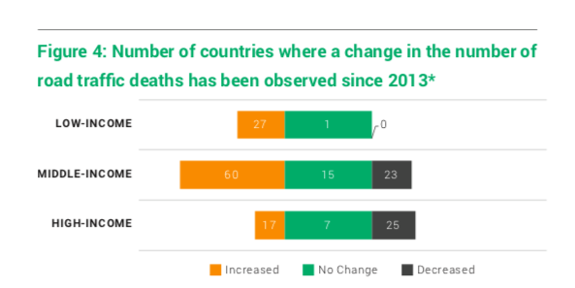

# Comparison of Russia with other countries:

For 2016**GNI per capita** (gross national income per capita) in Russia was $9,720

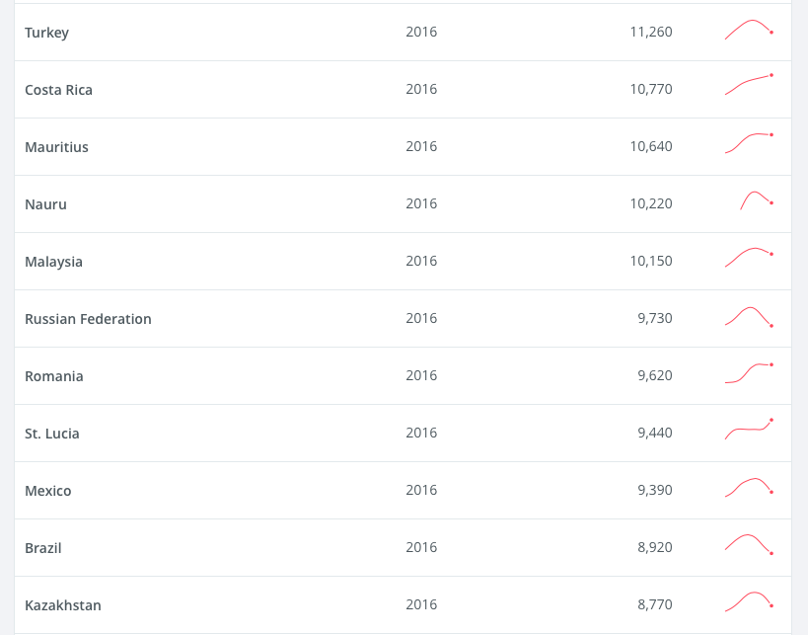

**In 2019 - $11260**

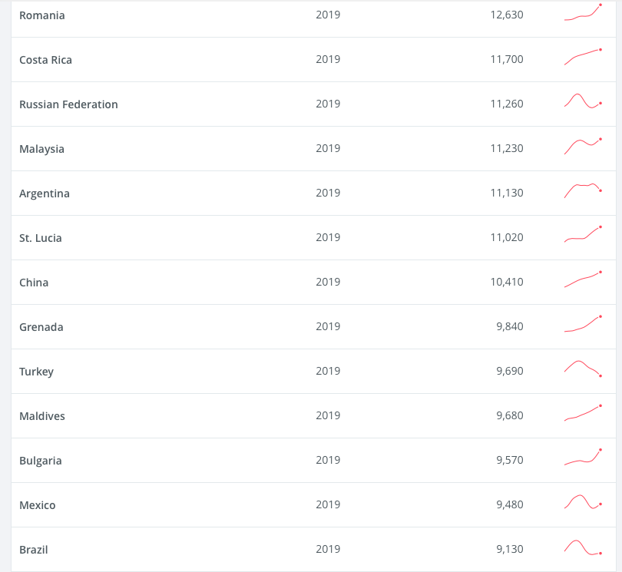

Countries with similar income levels in 2016[1] and in 2019: Turkey, Costa Rica, Brazil, Malaysia, Romania, Mexico[2]

* The number of cars per 1,000 people in Russia in 2020 was 388 units. Similar countries in terms of motorization from different continents (and similar GNI): Romania - 450 (2019), Brazil - 364 (2020), Turkey - 306 (2020), Malaysia - 433 (2015).[3]

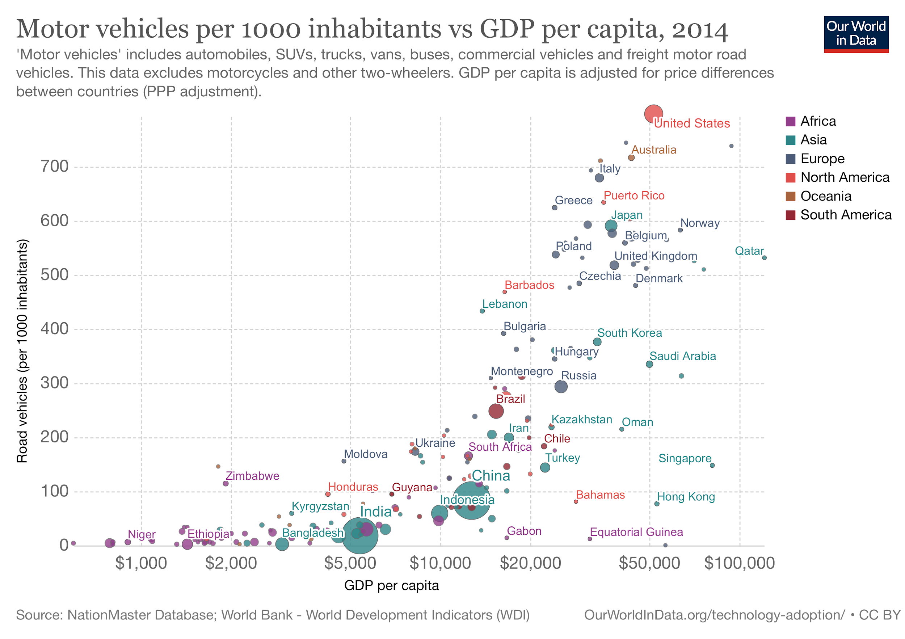[4]

**Total 5 countries for comparison from different continents: Russia, Turkey, Brazil, Romania, Malaysia (for 2016)**

## 

## 

## 

## 

## **Russia**:

3 most affected categories:bMore than half of the deaths on the roads were accounted for by drivers of passenger cars (32%) and their passengers (25%), the second group in terms of mortality are pedestrians (29%).

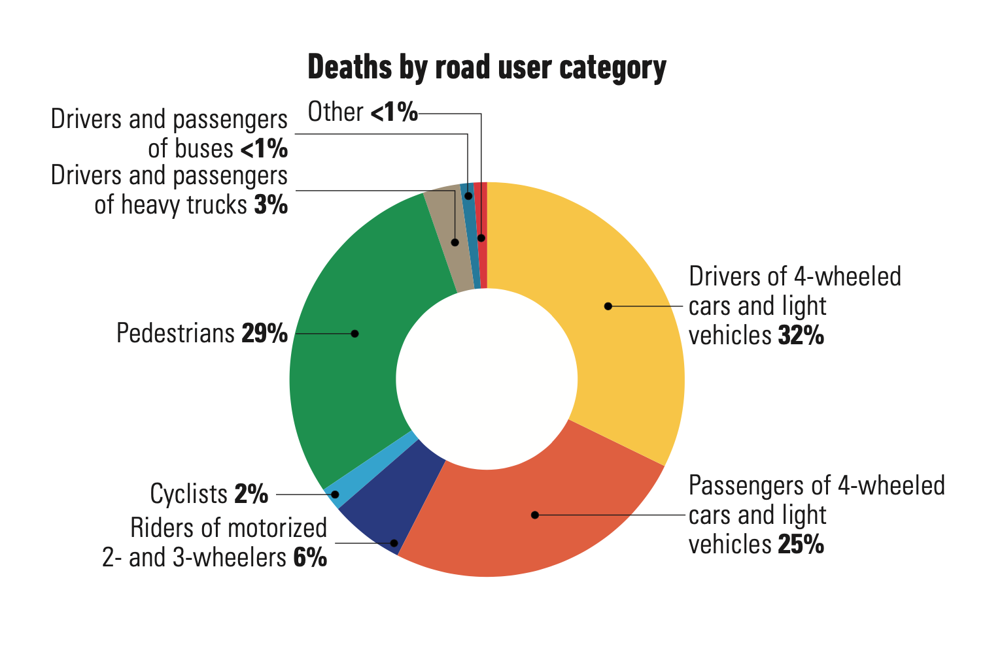

According to the Ministry of Internal Affairs, 20,308 people died on the roads of Russia, but according to WHO estimates, there were 5.5 thousand more deaths - 25,969.

**According to WHO estimates, there were 18 deaths per 100 thousand people.**

* Mortality has generally declined over the past 10 years.

Allowed alcohol:≤ 0.03 g/dl. **Fatal accidents due to him from the total - 23%**

Maximum speed: city - 60 km / h, village - 90 km / h, highway - 110 km / h.

Overall average: 87 km/h

* There are laws to limit the use of mobile phones in the hands and the mandatory seat belts for passengers and the driver.
* 388 cars per 1000 people (2020)

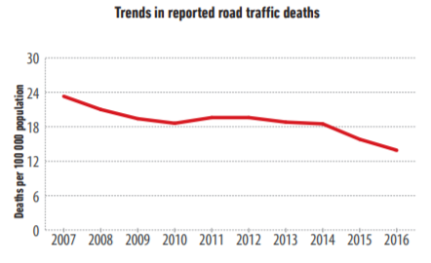schedule according to the Ministry of Internal Affairs

## Turkey:

3 most affected categories: 22% of deaths on the roads were accounted for by car drivers (22%), in second place was the “other” category, which amounted to 33% (probably, a significant part of them belongs to the category of car passengers), the second group in terms of mortality is pedestrians ( 23%).

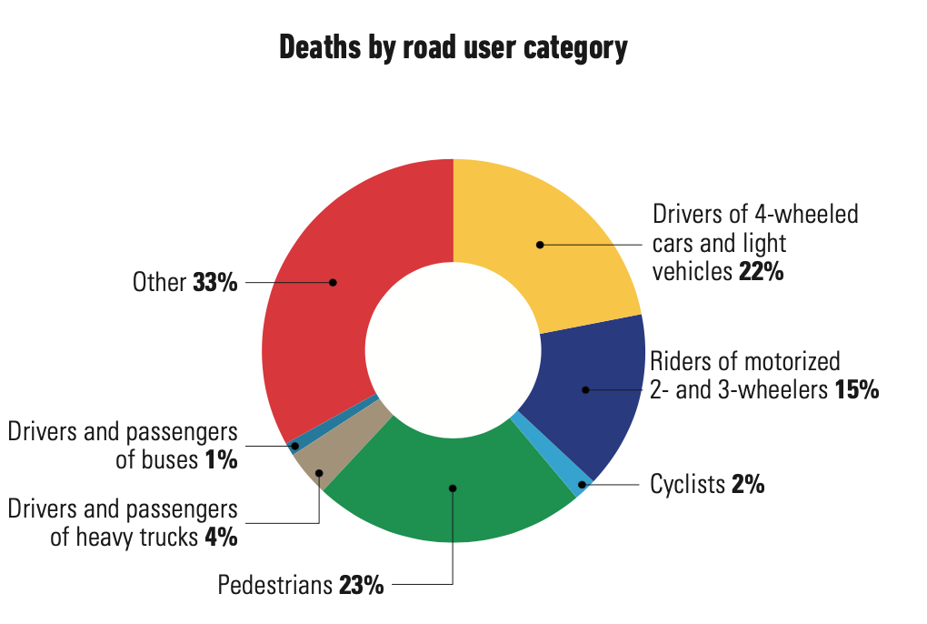

Turkey claims 7300 deaths, but WHO estimates their number at 9782, and the death toll is**100 thousand. - 12.3**

Allowed alcohol:≤ 0.05 g/dl. Of the number of deaths - less than 3%

Maximum speed: city - 50 km / h, village - 110 km / h, highway - 120 km / h. Overall average: 93 km/h

* Mortality has generally declined over the past 10 years.
* There are laws to limit the use of mobile phones in the hands and the mandatory seat belts for passengers and the driver.
* 306 cars per 1000 people (2020)

## 

## Brazil

3 most affected categories. Users of motorized two or three wheelers accounted for 31% of road deaths, followed by occupants of 4 wheelers and cars (23%) in second place, and the “other” category in third with 21% (probably a significant proportion of these to the category of car drivers).

Brazil reports 38,651 road casualties, WHO reports 41,007 and fatalities in**19.7 people per 100 thousand people**

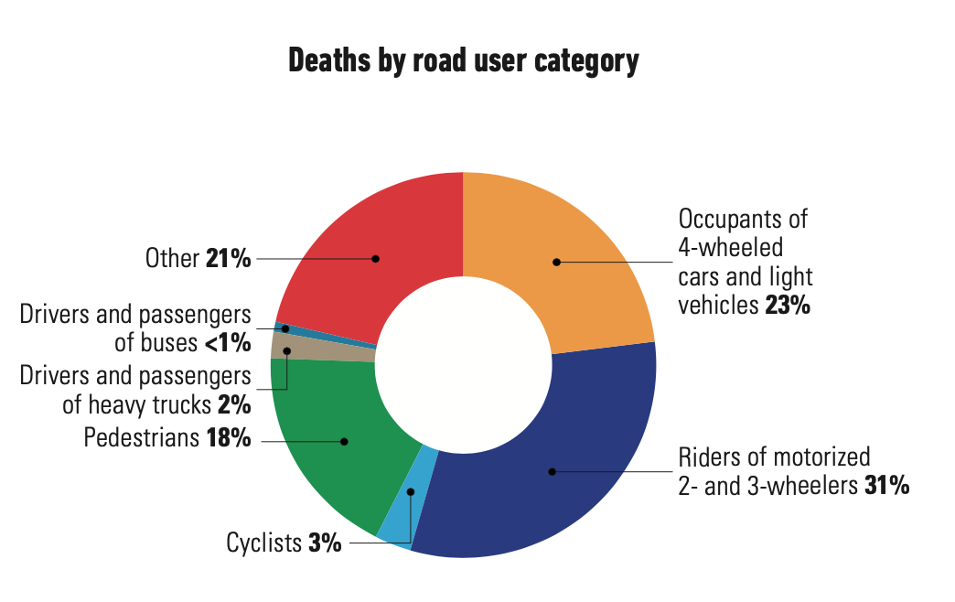

* Mortality over the past 10 years has basically fluctuated at the same level.

Allowed alcohol:≤ 0.05 g/dl. Of the number of deaths - 17%.

Maximum speed: city - 60km/h, village - 110km/h, highway - 130km/h,

Overall average: 100 km/h

* There are laws to limit the use of mobile phones in the hands and the mandatory seat belts for passengers and the driver.
* 364 cars per 1000 people (2020)
* 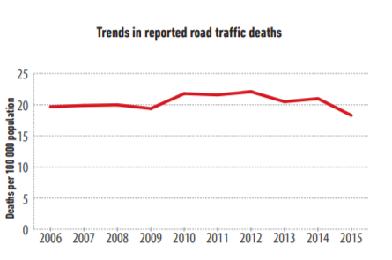

## Romania

3 most affected categories: palmost half of the deaths on the roads accounted for: drivers of passenger cars (26%) and their passengers (20%), but the first group in terms of mortality are pedestrians (37%).

Romania reported 1913 deaths, the WHO estimated there were 2044, and**10.3 deaths per 100 thousand people.**

Allowed alcohol:≤ 0.08 g/dl. Of the number of deaths - 6%

Maximum speed: city - 50km/h, village - 70km/h, highway - 130km/h,

Overall average: 83 km/h

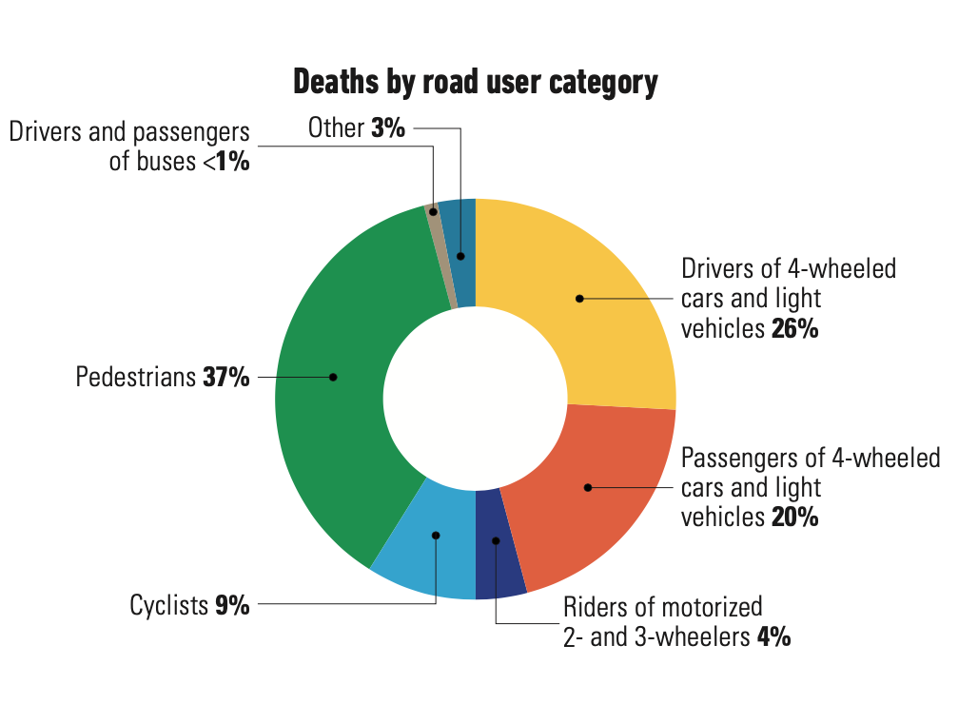

* There are laws to limit the use of mobile phones in the hands and the mandatory seat belts for passengers and the driver.
* Mortality over the past 10 years has generally decreased, but has increased slightly since 2013
* 450 cars per 1000 people (2019)

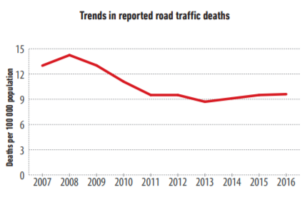

## Malaysia

Information on the categories of those killed on the roads is not available. Malaysia reports 7152 dead, WHO 7374 and**23.6 deaths per 100 thousand people.**

* Mortality over the past 10 years has basically fluctuated at the same level.

Allowed alcohol:≤ 0.08 g/dL. From hnumber of deaths - less than 1%

Maximum speed: urban - 90km/h, rural - 90km/h, highway - 110km/h,

Overall average: 97 km/h

* There is a law to restrict the use of mobile phones in the hands, but there is no rule for mandatory seat belts anddriver.
* 433 cars per 1000 people (2015)

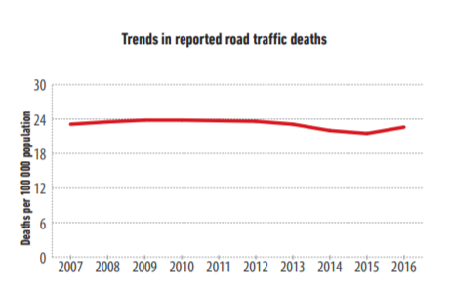

## TOTAL

**Russia:**

* **1st in alcohol severity and 1st in alcohol-related deaths[5] (almost a quarter of the total)**
* **2nd in overall average speed limit[6]**
* **in 3rd place in terms of the number of deaths per 100 thousand (after Malaysia and Brazil)**

Most of the restrictive measures of the mentioned five countries are quite similar. It is difficult to say that Russia stands out from their number with something other than alcohol-related deaths. Moreover, Russia has a positive trend, unlike Brazil and Malaysia, where there are more deaths per 100 thousand people.

plays a separate role**fleet status:** as of December 2020, the average age of a passenger car in Russia was 13.6 yearsFor[comparisons](https://www.autonews.ru/news/58259ecd9a79474743120198#:~:text=%D0%94%D0%BB%D1%8F%20%D1%81%D1%80%D0%B0%D0%B2%D0%BD%D0%B5%D0%BD%D0%B8%D1%8F%2C%20%D1%81%D1%80%D0%B5%D0%B4%D0%BD%D0%B8%D0%B9%20%D0%B2%D0%BE%D0%B7%D1%80%D0%B0%D1%81%D1%82%20%D0%BB%D0%B5%D0%B3%D0%BA%D0%BE%D0%B2%D1%8B%D1%85,%D1%82%D1%80%D0%B5%D1%82%D0%B8%20(32%2C4%25).), at the beginning of 2020, the average age of passenger cars in Europe is approximately 8.5 years, and in the USA - 9.2 years. According to experts, more than half (51.4%) of the cars currently in operation in Russia are over ten years old, while in Europe there are less than a third of such cars (32.4%). Such indicators cannot but affect road safety.

It should be noted separately that the level of motorization does not directly affect road safety - its highest rates are found in Western European countries.[7], which also has some of the lowest road fatality rates. This is largely due to the fact that cars are not used there on a regular basis, but for weekend trips and other movements..[8]

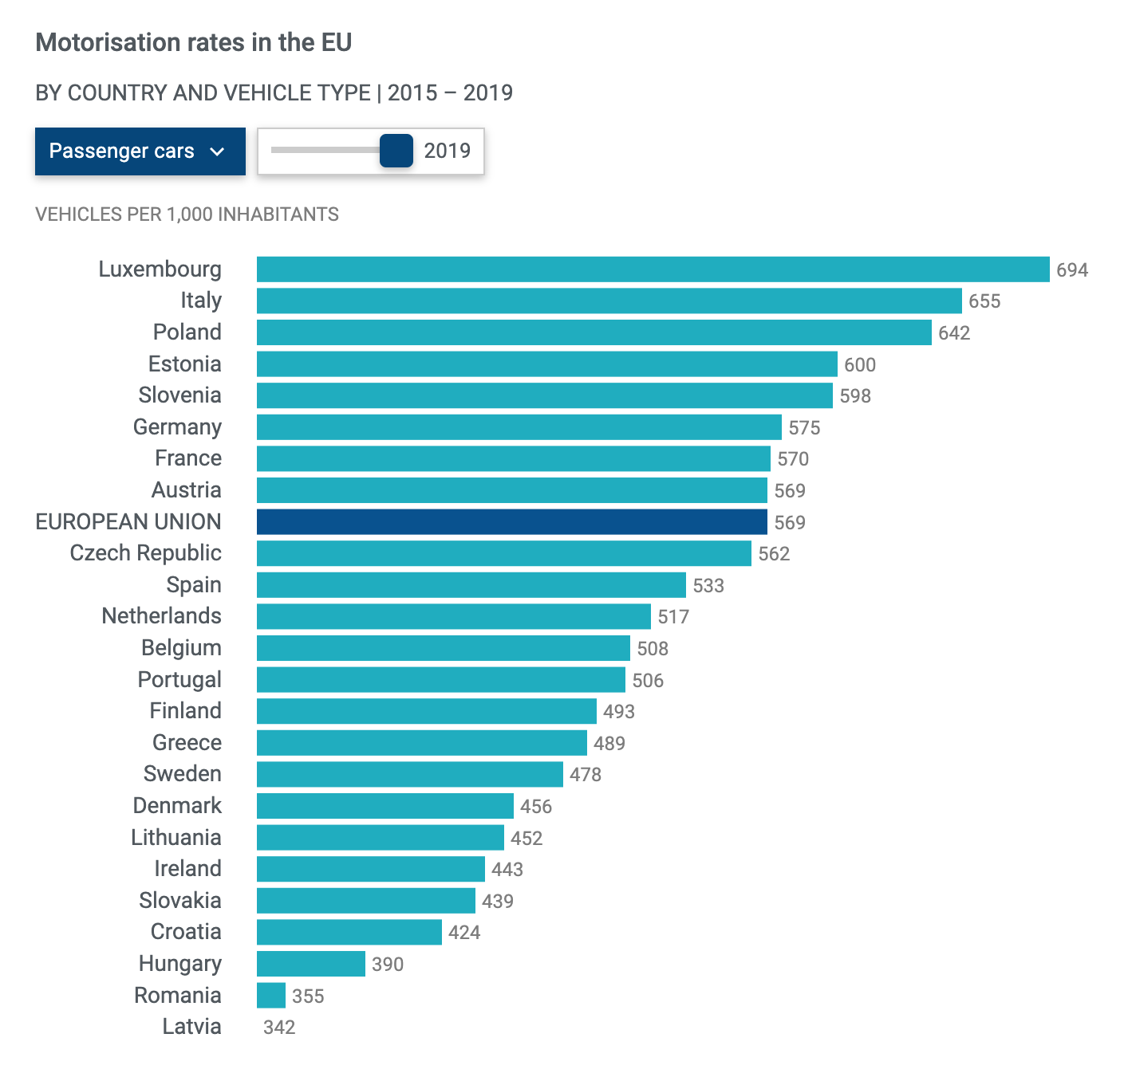

# Brief salignment of Russia with one of the safest countries - Norway and Sweden

## Norway:

The Vision Zero program became part of Norway's national transport plan in 2002.

V In 2019, there were almost fewer road deaths per 100,000 people in the world[9] - and amounted to 2.12. In Russia, this figure in 2019 was equal to 12 deaths.

In 2016, in Norway, this figure was also one of the lowest in the world - 2.7 deaths per 100,000 people. It has been declining since 2007, when it was equal to 5. In Russia in 2007, this figure was almost 24 deaths per 100,000 people.

* Russia almost halved mortality in 12 years, Norway almost 2.4 times

514 cars per 1000 people (2017)

## Sweden

In 2019, 3.14 deaths per 100 thousand people were recorded there (a total of 223 people died on the road). In 2016 - 2.8 deaths per 100 thousand, and in 2007 this figure was higher than 5 deaths. At the same time, Sweden is the founder of the Vision Zero approach (strives to zero deaths on the roads), but since the mid-2000s, it has succeeded less than Norway and even less than Russia in terms of improving dynamics.

Remarkably, in Sweden in 2016, 24% of deaths were related to alcohol - even more than in Russia. While in Norway this figure was 13% for that year.

In 2019 in Sweden 479cars per 1000 people (2017)

# [10]

# 

# 

# Three Development Scenarios for Russia

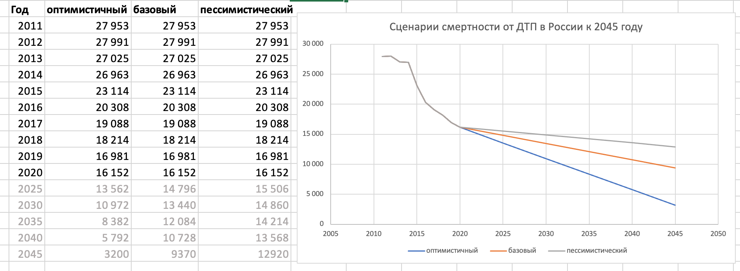In total, 16,435 people died on the roads in Russia in 2019, according to the Ministry of Internal Affairs. This number has halved since the beginning of the 2000s, but the trend is slowing down more and more.

## **Optimistic**

*The current value of Norway, adjusted for the population of Russia*

*2.2 deaths per 100,000 (based on current population)*

* If Russia moves at the same pace, it will end up in the same place where Norway is now at best**only a quarter of a century later.**This scenario is classified as optimistic, sinceIt is necessary to take into account the phenomenon of Russia's "low base" due to the deregulation of traffic rules in the zero years.
* It is necessary to introduce new significant measures both in terms of traffic rules and urban planning. For example, it is necessary to reconsider the policy of broadband highways within the city. In Moscow now about 26[11] major highways, where accidents regularly occur due to high speeds (legally it is from 80 to 100 km / h) and the lack of flow differentiation. At the same time, it is worth considering the lower motorization of Russia compared to Norway (and other developed) countries, so incentive measures are needed for the use of public transport.
* The two most obvious short-term measures (similar to Europe) are lowering the maximum speed limit within the city to 50 km/h and lowering the non-penalized threshold from 20 to 10 km/h.

## **Base**

*If over the next 25 years, the death rate will decrease in the same ratio as over the past 10 years and amount to 6.5 deaths per 100 thousand people.*

With minor new measures in the SDA and similar rates of road construction (from 2011 to 2018, 820 kilometers of roads were built in Moscow, and the total length of the capital's roads increased by 19 percent. The same pace of road construction - 100 kilometers of new roads per year - in Sobyanin promised to save 2019 for the next five years[12]) over time, the dynamics of mortality decline will even out, and even after 25 years it will not be possible to reach the level of the safest countries at the moment.

## **Pessimistic**

## **(most possible)**

*If over the next 25 years the mortality rate will decrease in the same ratio as over the past 5 years and amount to 9 deaths per 100 thousand population*

Since Moscow is a trendsetter in Russian realities, and more roads lead to even more accidents in absolute terms, it can be said with confidence that without a global revision of the road construction policy and new restrictive measures, a pessimistic scenario is likely. Under which the status quo and the current aforementioned practices will be maintained. In any case, the death rate will decrease, as this is a general trend throughout the world, in which the technological equipment and quality of machines play a significant role. Agiven the unfavorable economic environment, the number of obsolete cars in Russia can only increase.But in combination with other factors, its decline will become less and less noticeable over time. Russia will not even reach the current level of the safest countries on the roads with the current vector of development in the coming decades.

# **Regional difference**

In 10 regions with the most road traffic victims per 100,000 in 2019

person includes:

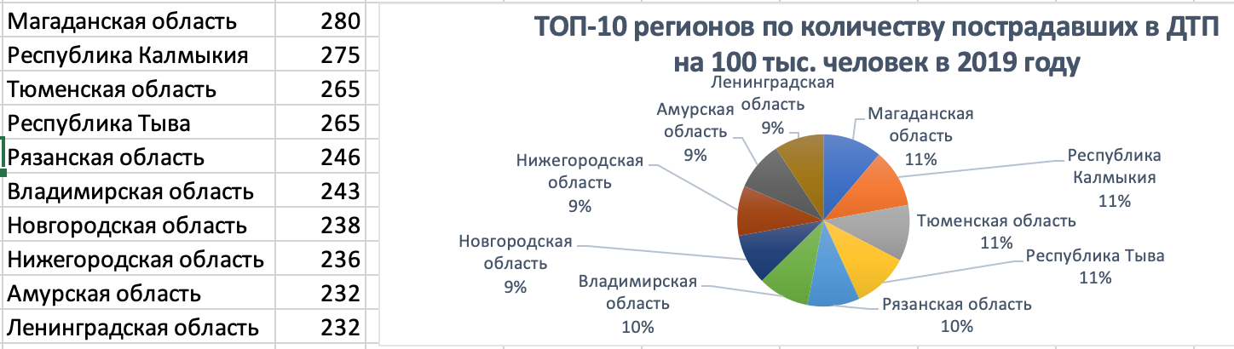

**Number of fatalities (in 2017) in regions with the highest number of road accidents (in 2019)**

| **Region** | **per 100 thousand people** |
| --- | --- |
| Magadan Region | 24.7 |
| Republic of Kalmykia | 25.2 |
| Tyumen region | 13.8 |
| Republic of Tyva | 31.1 |
| Ryazan Oblast | 19.8 |
| Vladimir region | 21.1 |
| Novgorod region | 23.2 |
| Nizhny Novgorod Region | 12.5 |
| Amur region | 18.1 |
| Leningrad region | 23.9 |

This list does not match the top 10 regions in terms of the number of deaths in 2017. They include (in descending order):

1. Tyva (31.1),
2. Kalmykia (25.2),
3. Magadan region (24.7),
4. Leningrad region (23.9),
5. Novgorod region (23.2),
6. Kamchatka Territory (21.6),
7. Vladimir region (21.1),
8. Lipetsk region (20.8),
9. Republic of Adygea (20.7)
10. Sakhalin Region (20.7)

In 2019, in 13 out of 85 regions, more than 100 people died on the roads per 1,000 injured.[13] The first 4 places are occupied by the regions of the North Caucasus, but Chechnya stands out even from among them - 251 people per 1000 victims died there. It is also important to understand that getting into any road accident in these regions is already associated with a high probability of death. One of the explanations for the first 4 places in this indicator of the Caucasus regions may be that wearing a seat belt is considered bad form there.

The remaining subjects of their top 10 are located in different parts of Russia, including the Moscow region. At the same time, Moscow (40 deaths per 1,000 injured) is in third place from the bottom in this indicator. Better than her only St. Petersburg and Sevastopol, which stand out from the general list - 28 and 23 per 100 thousand dead, respectively. This may be due to the fact that much more accidents occur in large cities.

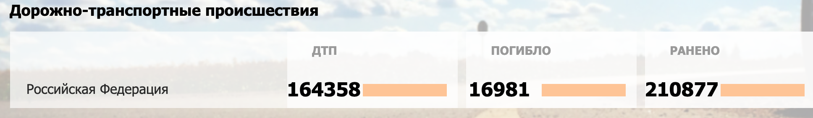

**Both graphs are made on the basis of official statistics of the Ministry of Internal Affairs, but it was found that only 8% of accidents registered under OSAGO fall into their database[14]. Therefore, it is important to understand that the data of the Ministry of Internal Affairs do not take into account accidents without victims in principle. In addition, in addition to the total number of 2 million accidents per year in Russia, another 1 million are not registered at all.**

**There is no breakdown by region by the number of annual accidents on the website of the Ministry of Internal Affairs, but you can see the data by month: August and October are the most dangerous.**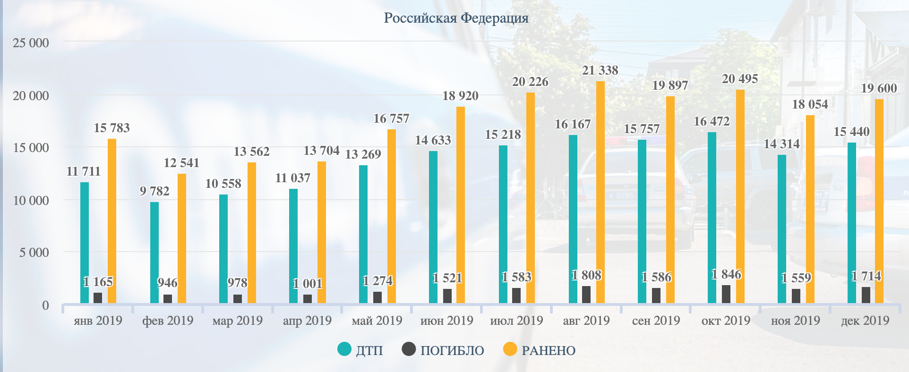

# 

# Basement

## materials

[***https://ac.gov.ru/files/content/19540/taksi-avariinost-final-2311-pdf.pdf***](https://ac.gov.ru/files/content/19540/taksi-avariinost-final-2311-pdf.pdf)

### Automobilization

1. <https://hal.archives-ouvertes.fr/hal-01960575/document>

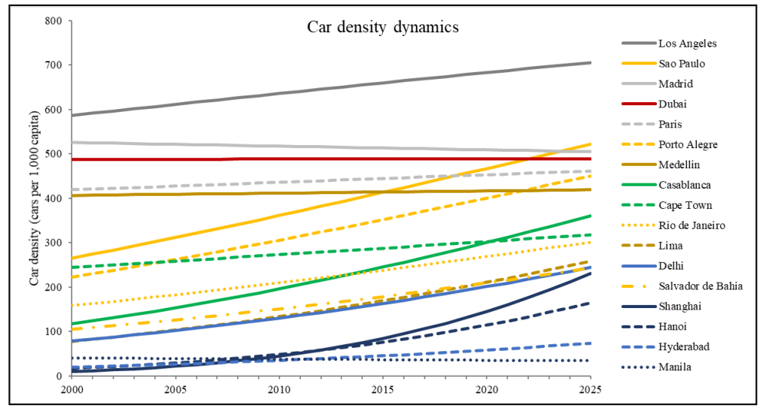

**2)** [**https://www.sciencedirect.com/science/article/pii/S2352146520305299**](https://www.sciencedirect.com/science/article/pii/S2352146520305299) **-**

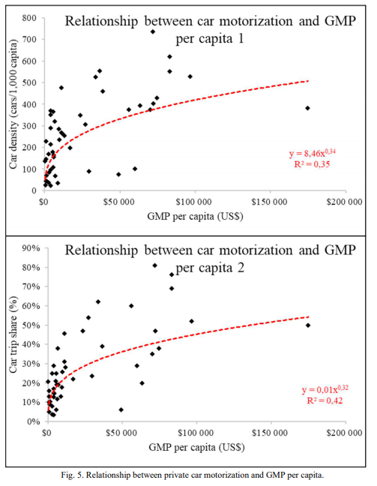

3) <https://www.bbc.com/future/article/20120510-more-cars-more-accidents>

### Current analy-e reports

1) **Road Safety in Low-Income Countries: State of Knowledge and Future Directionsе (2019)**

<https://www.mdpi.com/2071-1050/11/22/6249/pdf>

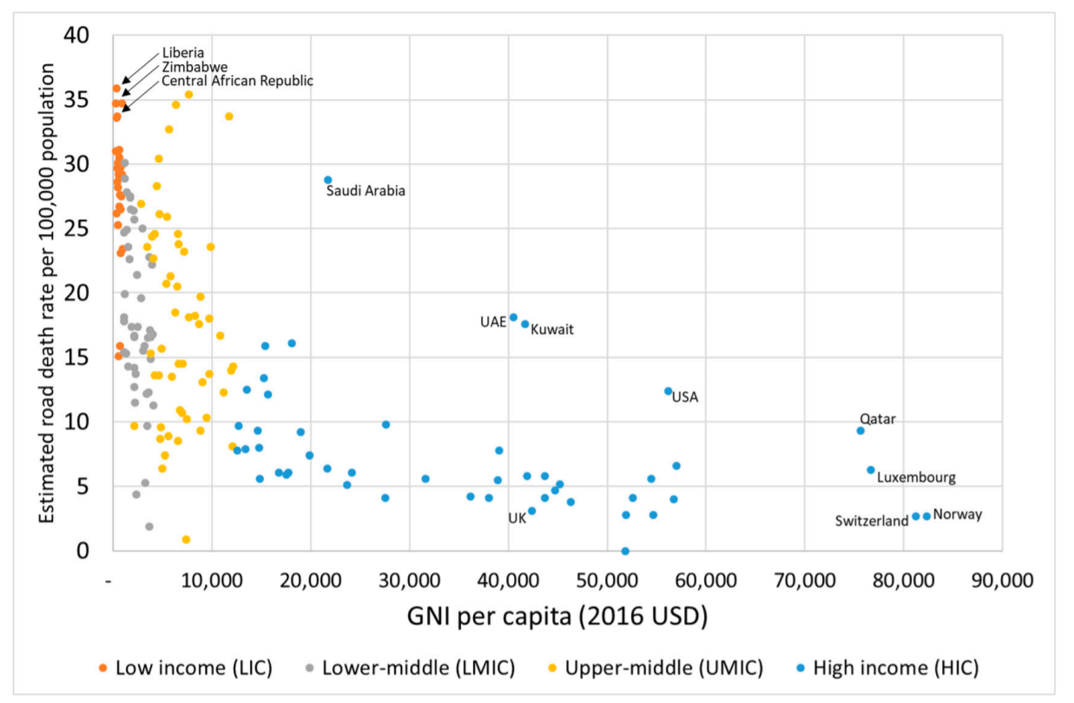

2) **Global status report on road safety (2018) - *topical***

<https://www.who.int/publications/i/item/9789241565684>

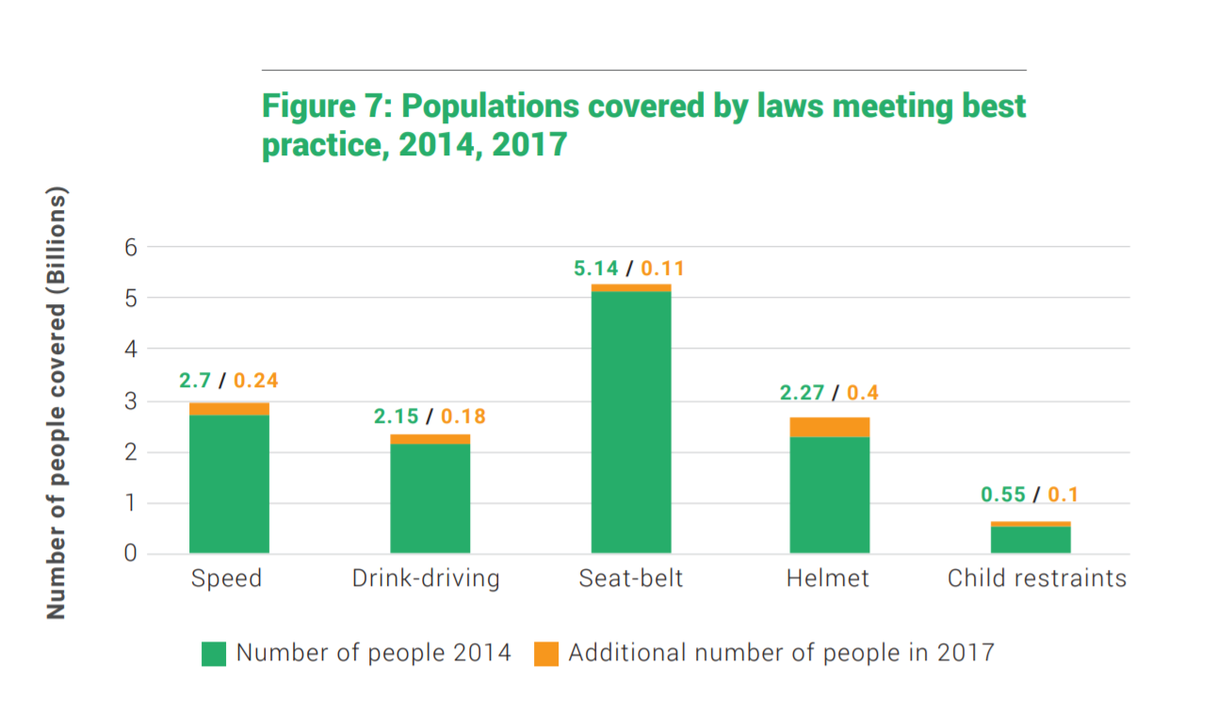

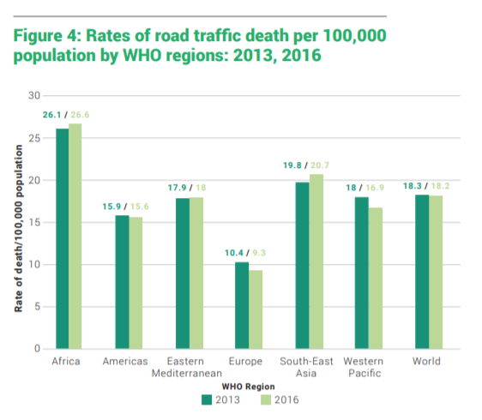

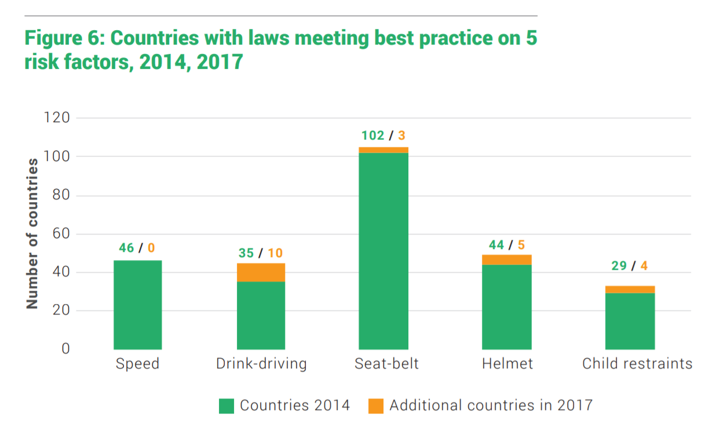

**3) Traffic Safety in Developed and Developing Countries: A Comparative Analysis (2018) -** *there is an infographic*<https://www.researchgate.net/publication/330284425_Traffic_Safety_in_Developed_and_Developing_Countries_A_Comparative_Analysis>

# 4) Motorization of Asia:<https://www.sciencedirect.com/science/article/pii/S0386111214601837>

### Legacy Reports:

* **Global status report on road safety (2009)**

<https://www.who.int/violence_injury_prevention/road_safety_status/report/en/#:~:text=Approximately%201.3%20million%20people%20die,million%20sustain%20non%2Dfatal%20injuries.&text=The%20results%20suggest%20that%20in,while%20enforcement%20should%20be%20strengthened>.

* **Global status report on road safety (2015)**

<https://www.who.int/violence_injury_prevention/road_safety_status/2015/en/>

* **RS in 10 countries (2010)**

<https://www.grsproadsafety.org/wp-content/uploads/RS-10-factsheet-V4-web.pdf>

* **Road Safety Development Index (RSDI) Theory, Philosophy and Practice (2007)**

<http://www.diva-portal.org/smash/get/diva2%3A23510/FULLTEXT01.pdf>

* **ROAD SAFETY IN FIVE LEADING COUNTRIES** (ca. 2006)

<https://www.codatu.org/wp-content/uploads/Road-safety-in-five-leading-countries-Rifaat-SHOUKRALLAH.pdf>

# **An examination of the national road-safety programs in the ten world’s leading countries in road safety (2012)**

<https://etrr.springeropen.com/articles/10.1007/s12544-012-0081-x>

* **Road Safety in Developing Countries (2014) -** *there is an infographic*

<https://www.researchgate.net/publication/269547854_Road_Safety_in_Developing_Countries>

* Good research, but 2009  
  <https://www.itf-oecd.org/sites/default/files/docs/p03_borsos.pdf>

### Cases

**Sweden**

* **Vision Zero 20 years - *(2017)***

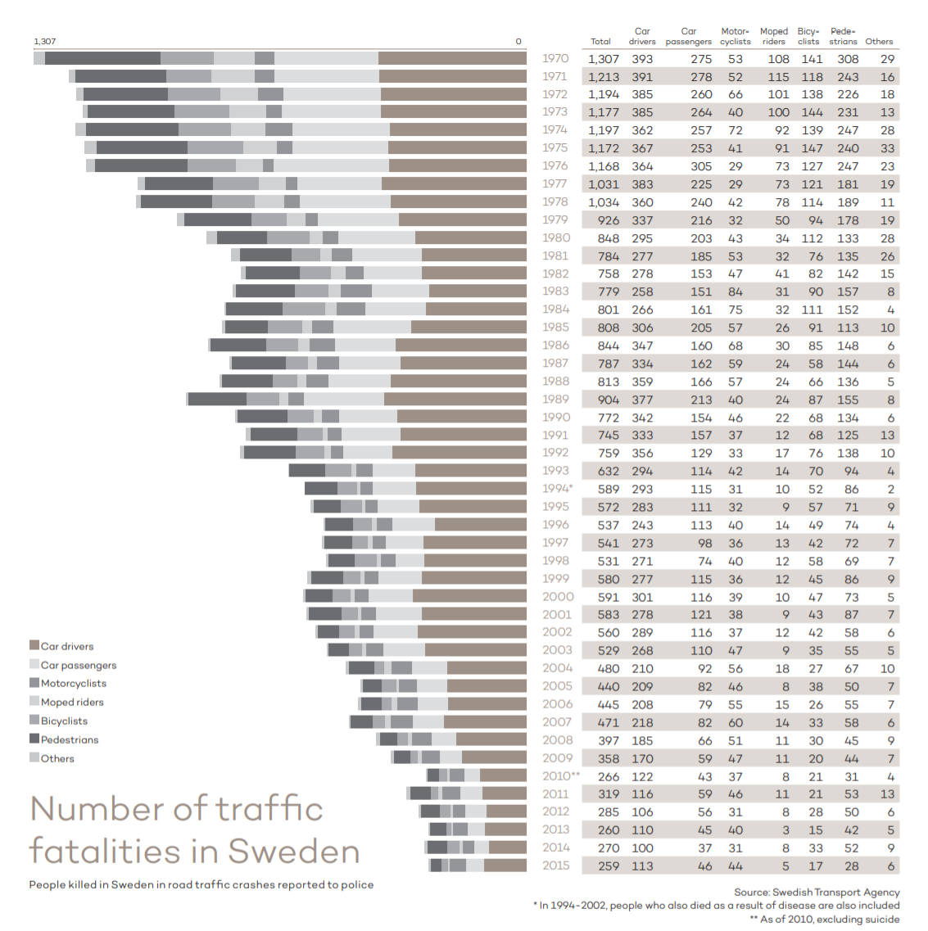

<https://www.afconsult.com/contentassets/8f0c19f4f7d24aa5bdbfd338128391ec/2017057-17_0194-rapport-nollvision-eng_lr.pdf>

**NY**

* **Dataset and infographics on the implementation of the program in New York**<https://data.cityofnewyork.us/Transportation/Vision-Zero-Base-Report/ph7v-u5f3>
* **More on NY:** <https://www1.nyc.gov/content/visionzero/pages/open-data>

**Georgia**

* **Road Safety Performance Review Georgia** (funded by the UN)

A large analytical review of 2018 on what has been done and what is planned to improve road safety

<https://unece.org/DAM/trans/roadsafe/unda/GE_RSPR_WEB_e.pdf>

### Articles

* **VISION ZERO Setting a higher standard for road safety (2018) -** *analytical review of the program and its usefulness (main cases - Australia and Sweden); there is a useful infographic*

<http://cdn.wsp-pb.com/33uj8u/vision-zero-advertorial-dec2018.pdf>

* **Interactive map of cities with zero deaths from 2009 to 2013:**
* **only one city (Gothenburg) with a population of over 500,000**
* **14 more cities with a population of over 250 thousand (3 of them - two years with zero deaths)**

<https://www.dekra-vision-zero.com/map/>

* [**How ‘zero’ became the biggest number in road safety**](https://thecityfix.com/blog/how-zero-became-biggest-number-road-safety-vision-zero-sweden-new-york-city-stephen-vikell-ben-welle/) (2014)

*a small overview of the history of Vision Zero*

<https://thecityfix.com/blog/how-zero-became-biggest-number-road-safety-vision-zero-sweden-new-york-city-stephen-vikell-ben-welle/>

## Notes

***Road safety (27.02)***

***Hypothesis 1: Is there a difference between countries in terms of income and motorization?***

1. *Group of countries by number of cars and economic development*

*+ Dynamics by country - who goes where?*

*trajectories of selected countries over time by number of deaths*

*Alternative: the current comparison of countries among themselves, and decompose Russia into regions*

1. ***where we are relative to the world (make a representative sample)***
2. ***how much more do we have to move to catch up with the world (conditional Sweden)***
3. ***Difference in regions across Russia***

*The key question is how up-to-date should the data be? The last 5 or 10 or 15 years?*

1. In the latest WHO report, most of the data is taken from this year
2. The island states of Saint Lucia and Mauritius are not taken for comparison; Romania is included as the only EU country
3. Costa Rica is excluded because of excellent data, Mexico - because there is Brazil.<https://en.wikipedia.org/wiki/List_of_countries_by_vehicles_per_capita>
4. <https://ourworldindata.org/grapher/road-vehicles-per-1000-inhabitants-vs-gdp-per-capita?time=latest>
5. It is worth considering the specifics of Malaysia and Turkey as Muslim countries
6. taking into account the non-penalty threshold of 20 km / h, probably on the last
7. https://www.acea.be/statistics/article/vehicles-per-capita-by-country
8. <https://setis.ec.europa.eu/sites/default/files/reports/Driving_and_parking_patterns_of_European_car_drivers-a_mobility_survey.pdf>
9. If you do not take into account small and island states
10. https://www.rbc.ru/economics/19/11/2019/5dd282449a794778c3ee8b4e
11. http://logist4u.ru/stati/glavnye-transportnye-magistrali-mos/
12. <https://rg.ru/2019/07/11/reg-cfo/za-chetyre-goda-v-moskve-poiavitsia-bolee-500-kilometrov-novyh-dorog.html>
13. <https://ria.ru/20200224/1564977090.html>
14. <https://cbr.ru/analytics/insurance/overview_insurers/>